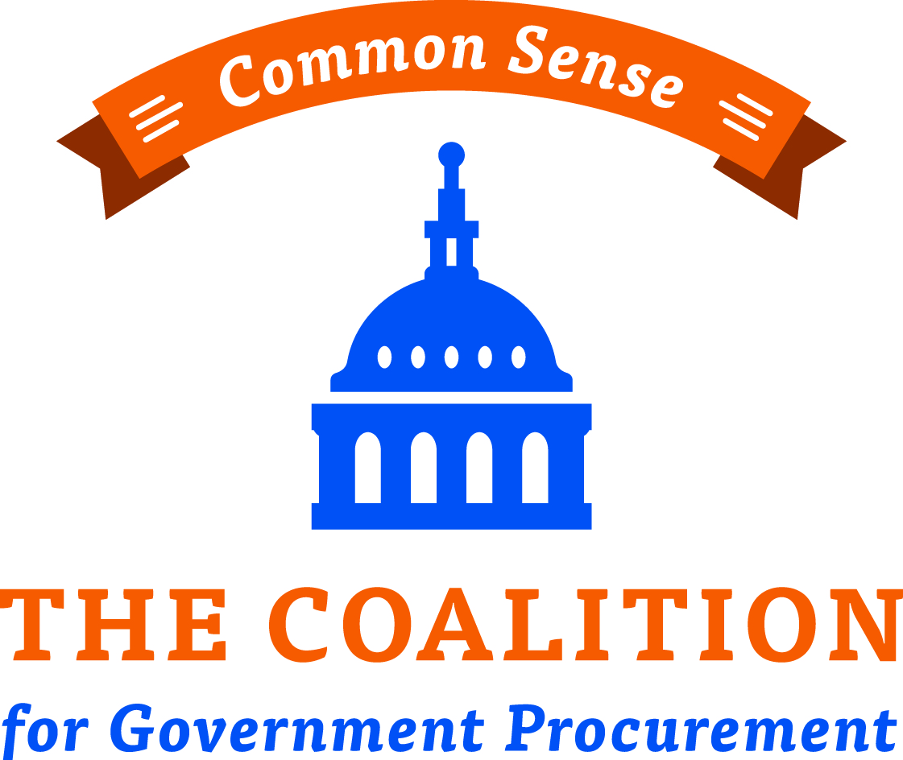

Coalition for Government Procurement
Fourth Annual Healthcare Forum

7:30 - 8:30
Registration & Light Breakfast

8:30 - 8:45
Welcome
Roger Waldron - President, Coalition for Government Procurement

8:45 – 9:00
Legislative Outlook
Former Congressman Jeff Miller – Senior Legislative Advisor, McDermott Will & Emery

9:00 - 9:30
DHA Keynote Address – An update on the MHS Reorganization
Guy Kiyokawa – Deputy Director, Defense Health Agency (CONFIRMED)

9:30 to 9:45
Break

9:45 to 10:15
Improving Clinical Input in the MSPV Program
Tammy Czarnecki – Assistant Deputy Undersecretary of Health for Administrative Operations, VA

10:15 to 11:15
VA Study on Fair and Reasonable Pricing - Update
Tom Leney – Director Small & Veteran Business Programs, VA (CONFIRMED)

11:15 to 11:30
Break

business intelligence SESSIONS 11:30 - 12:30

1. Health IT Update
Keith Nakasone – Deputy Assistant Commissioner, IT Category, GSA (CONFIRMED)
John Tenaglia – Head of Contracting, Defense Health Agency (CONFIRMED)
___________________________________________________________________
2. DOD Pharmaceutical Update
David Bobb – Chief of Pharmacy Operations, Defense Health Agency (CONFIRMED)
___________________________________________________________________
3. DHA/VA Shared Services
ECAT System Adoption, DAPAs and More

Dan Keefe – Medical Director of Supply Operations, Defense Logistics Agency (CONFIRMED)

Lunch 12:30 – 1:30

BUsiness intelligence Sessions 1:30 - 2:30

1. MSPV-NG, Formulary, MSPV 2.0 and More

Rick Lemmon – Acting Chief Procurement and Logistics Office, VHA (CONFIRMED)
Jaime Friedel – Procurement Director, SAC (CONFIRMED)
___________________________________________________________________
2. VA Pharmaceutical Update

Tom Emmendorfer – Deputy Chief Consultant, Pharmacy Benefits Management Service, VA

