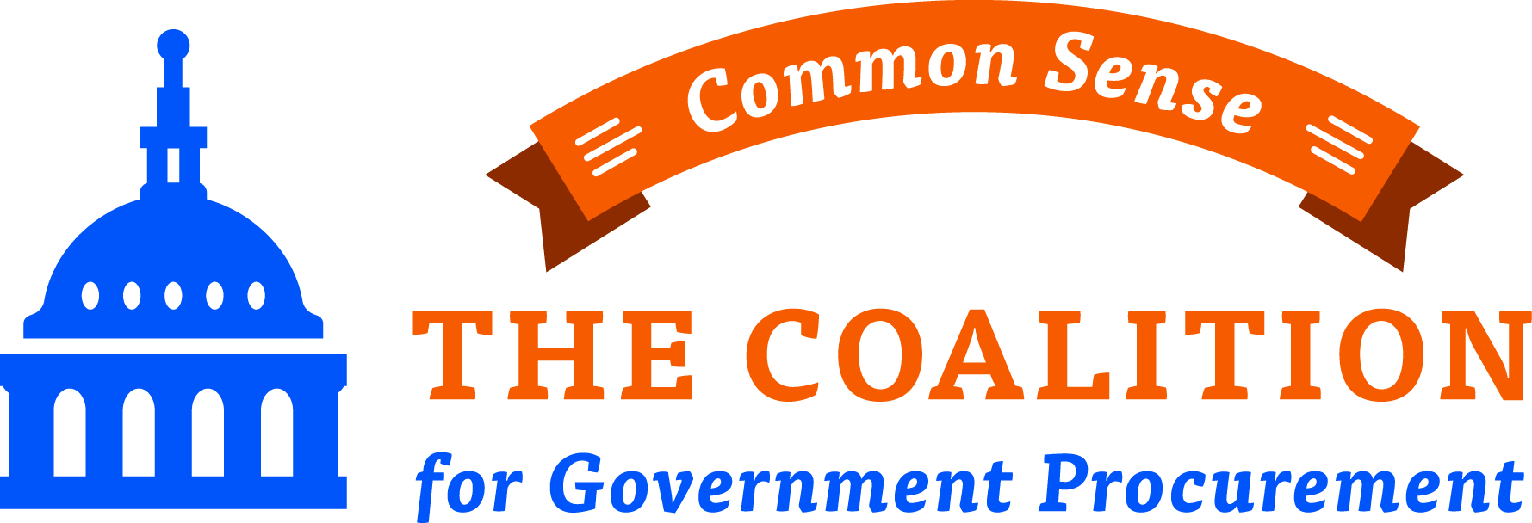

Spring Training Conference - April 28, 2015
Fairview Park Marriott, Falls Church, VA

8:15
Welcome
Roger Waldron - President, Coalition for Government Procurement

8:30 - 9:15
Keynote: Managing The Business of Government – GSA’s Role
Denise Turner Roth - Acting Administrator, General Services Administration

9:15 – 10:00
Ten Tips for Capturing The Federal Market in 2015 And Beyond
Ray Bjorklund – President, BirchGrove Consulting
Cameron Leuthy - Senior Budget Analyst, Bloomberg Government
Wendy Frieman - Principal Consultant, Lohfeld Consulting Group
Moderator: Bill Gormley - President, The Gormley Group

10:00 to 10:15
Break

10:15 to 11:00
The Impact Of Small Business Policy On The Federal Market - A Conversation With Jon Shoraka, SBA
A. John Shoraka - Associate Administrator of Government Contracting and Business Development, Small Business Administration
Moderator: Angela Styles –Partner, Crowell & Moring

11:00 to 11:45
Legal Panel: From Risks To Rewards - Strategies For Managing Liabilities Of Your Federal Contract
Jonathan Aronie - Partner, Sheppard Mullin
David Dowd - Partner, Mayer Brown
Jason Workmaster - Partner, McKenna Long & Aldridge

12:00 to 2:00
Lunch:
The Status of MAS Reform – Update On GSA Initiatives And What They Mean For Your Business
Kevin Youel Page - Deputy Commissioner, Federal Acquisition Service, General Services Administration

4:30 - 5:30
Networking Reception
Please join us in the main foyer and outside patio for a networking reception and breakout session information sharing!

Breakout Session 1 of 2, Options 1-4
2:15 to 3:15

1. The Ultimate Helpdesk - SAM, GSA Advantage And Ebuy
Can’t get your documents loaded? Using timely work-arounds? Attend this session for help interfacing with federal systems.

Liz Delnegro - Associate CIO for Acquisition IT, General Services Administration
Tim Dempsey - Systems Chief, Federal Acquisition Service, General Services Administration
Judith Zawatsky - Director of Outreach & Stakeholder Management, Integrated Award Environment, General Services Administration

2. How Contractors Can Improve The Audit Process – The Government’s Perspective

Theodore Stehney - Assistant IG for Auditing, General Services Administration Office of Audits
Maureen Regan - Counselor to the Inspector General, Department of Veterans Affairs
Jennifer Kang - Fairfax Branch Manager, DOD Contract Audit Agency (DCAA)

3. Cybersecurity: What Change Should Federal Contractors Anticipate?
Cybersecurity is a key objective of government. What is the role of federal contractors in achieving that goal? Find out and understand the requirements that are coming to your contract.

Donald Davidson - Chief, Outreach, Governance, Science & Standards In Lifecycle Cybersecurity Risk Management, Department of Defense
Joe Jarzombek - Director of Software & Supply Chain Assurance, Department of Homeland Security

4. The Future Of Sustainable Government—From Ecolabels To Green Buildings

Dana Arnold – Director, Program Analysis Division, Federal Acquisition Service, General Services Administration Office of Acquisition Management
Alison Kinn-Bennett - ‎Senior Advisor for Sustainability, Environmental Protection Agency

Breakout Session 2 of 2, Options 1-3
3:30 to 4:30

1. GSA Technology Contracts
GSA offers federal agencies a full range of IT and telecommunications products and services using its IT Schedules program and a series of GWACs. This session will offer valuable updates and an opportunity to have question answered on the wide range of GSA technology contracts.

Mark Day - Deputy Assistant Commissioner, Integrated Technology Service, General Services Administration
Christopher Fornecker - Director of the GWAC Program, Federal Acquisition Service, General Services Administration
Kay Ely - Director, IT Schedules Acquisition Center, Federal Acquisition Service, General Services Administration
Amando Gavino - Director of the Network Services Program, Federal Acquisition Service, General Services Administration

2. Government Wide Acquisition of Professional Services

Tiffany Hixson - Regional Commissioner, Federal Acquisition Service, General Services Administration
Ralph Lentz – Acting Director, Management Services Center, Federal Acquisition Service, General Services Administration, Region 10

3. GSA, Federal Acquisition Service, General Supplies and Services (GSS) Business line Update
This important GSA business line is home to all of GSA Schedules, other than Information Technology and Travel/Transportation. Attend this session to get an update on initiatives and priorities impacting your Schedule contract. This breakout session is an opportunity to ask your questions about negotiation practices, pricing tools, the modification process, awarded strategic sourcing initiatives, and more.

Shaloy Castle-Higgins - Director, Greater Southwest Acquisition Center
Peter Han - Director, National Administrative Services and Office Supplies Acquisition Center
Kim Kittrell - Supervisory Contracting Officer, Center for Facilities Maintenance and Hardware (CFMH)
John Breen – Supervisory Contract Specialist, Integrated Workplace Acquisition Center (IWAC)
Gregory Rollins - Director, Center for Innovation Acquisition Development

